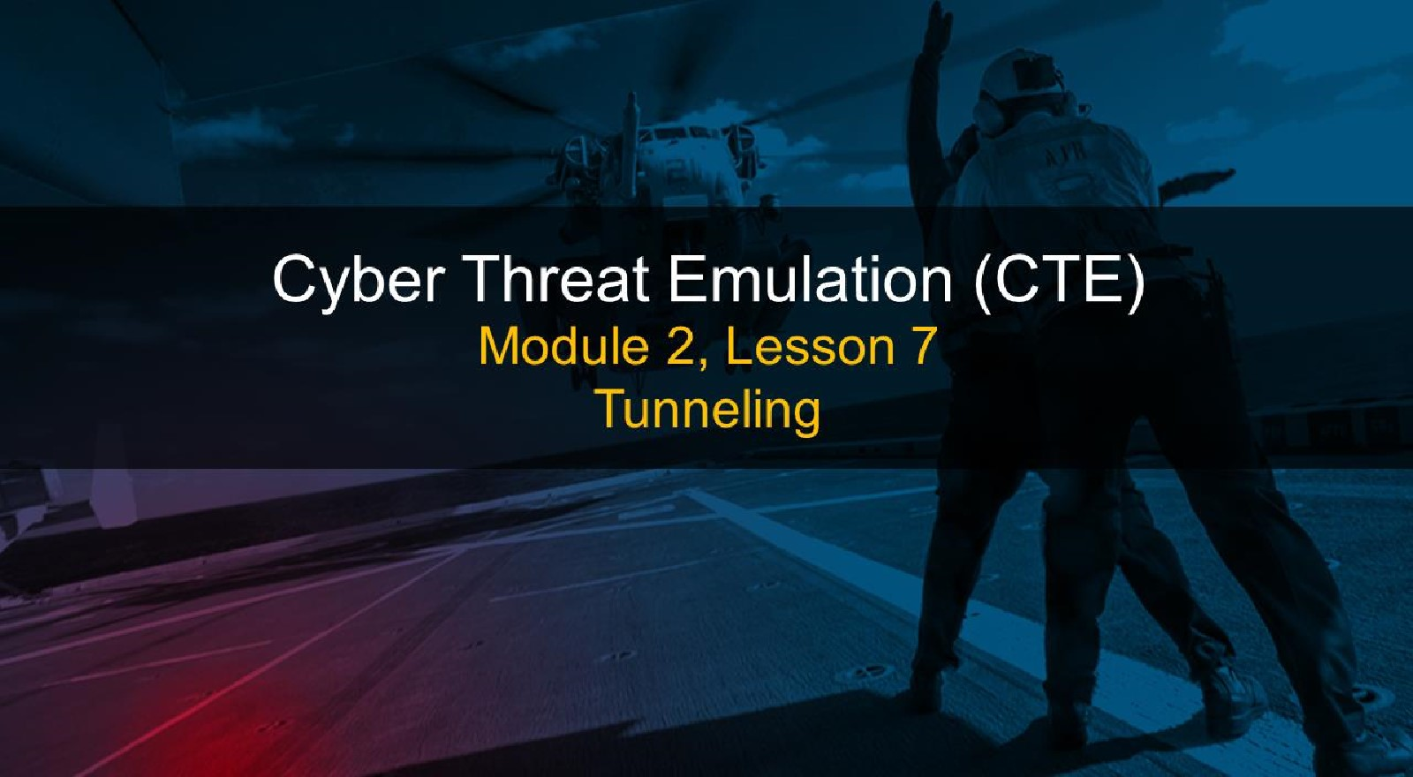

# Course Objectives

After completing this course, students will be able to:

* Summarize the CTE squad's responsibilities, objectives, and deliverables from each CPT stage
* Analyze threat information
* Develop a Threat Emulation Plan (TEP)
* Generate mitigative and preemptive recommendations for local defenders
* Develop mission reporting
* Conduct participative operations
* Conduct reconnaissance
* Analyze network logs for offensive and defensive measures 

I

# Course Objectives (Continued)

Students will also be able to:

* Analyze network traffic and tunneling protocols for offensive and defensive measures
* Plan non-participative operations using commonly used tools, techniques and procedures (TTPs)

# Module 2: Threat Emulation (Objectives)

* Conduct reconnaissance
* Generate mission reports from non-participative operations  Plan a non-participative operation using social engineering
* Plan a non-participative operation using Metasploit
* Analyze network logs for offensive and defensive measures
* Analyze network traffic and tunneling protocols for offensive and defensive measures
* Plan a non-participative operation using Python
* Develop fuzzing scripts
* Develop buffer overflow exploits

I

## Module 2 — Lesson 7: Tunneling (Objectives)

* Describe the principles and methods of tunneling network traffic
* Describe the different uses of SSH
* Describe the differences between forward and reverse tunnels when using

SSH

* Explain how to redirect traffic using SSH forward and reverse tunnels
* Use SSH to redirect and tunnel network traffic through multiple hosts
* Analyze network tunneling diagrams
* Describe SSH reverse tunnels and their purpose
* Recognize the difference between tunneling and redirecting network traffic
* Implement reverse SSH tunnels
* Analyze traffic to locate covert channels

# Network Engineering Blues

Sometimes traffic does not play nicely with pipes it needs to go through

|  |  |
| --- | --- |
|  | Protocol is unsupported  Your ISP does not route IPv6 yet |
|

Between privately addressed networks

Intervening links will not route

|  |  |  |
| --- | --- | --- |
|  |  |  |
|  | Someone  wants to spy on your traffic |

## Tunneling

Tunneling is the solution

 Put traffic you want to send inside a protocol that can get to your desired destination

|  |
| --- |
| Example: VPN |
| * Bob cannot directly access his company's internal network from home * Bob uses a  VPN client on his laptop to connect to his company's VPN   concentrator, creating a  tunnel  Using the tunnel, Bob's VPN client encapsulates and encrypts all traffic  destined for the company network and sends it to the concentrator |
|  |

# IPv6 to IPv4 Tunneling

## IPv6 migration: <25% of world ISPs have adopted IPv6

* Makes it tough to be an early adopter
* Multiple solutions proposed—ISATAP, Teredo
* 6t04 Tunneling



* Put IPv6 packet in an IPv4 packet
* Methodology is standardized, IPv4 next protocol 41
* Packet routes over IPv4 to the other endpoint
* IPv4 framing is stripped at the other end, and IPv6 packet is processed

## Finer Points of Tunneling

* Tunneling can be at any layer of the network stack:
* Lower levels usually integrated into OS
* Higher levels typically into application software
* Tunneling can put lower layers into other ones.
* Ethernet over IP why not? (Why?)
* As long as you have the software on both ends to process it, you can tunnel any protocol over another

## Secure Shell (SSH)

SSH is used for encrypted terminal access across a network

* SSH server (sshd) listens on a bound port 22
* SSH client initiates a TCP session to the server

SSH has multiple channels/tunnels

* Tunnels can be set to listen on a preconfigured port
* Tunnels forward packets to the SSH peer
* The receiving end sends packets to a preconfigured destination 

### Forward vs. Reverse

Each channel opens only one listener

|  |
| --- |
| Reverse Tunnel |
| * SSH server opens the tunnel listener * SSH client redirects received data Call back: Expect something else to establish a connection |
|  |

#### Forward Tunnel

* SSH client opens the tunnel listener
* SSH server redirects received data
* Call forward: Initiate a connection to the remote machine

### Tunnels in Detail

Tunnel setup:

* Issue command on client:
* s sh

L<lis port>:<dst ip>: <dst port >

* Client connects to server 1 with userA credentials
* Client/server negotiates a channel for the tunnel
* Client creates a listening socket on < lis port >
* Server redirects traffic traveling through tunnel to

<dst ip•.dst port >

#### Tunneling in Detail

Connection:

* Connect to the tunnel listener using client software (e.g., ssh, telnet, web browser, netcat)
* Client negotiates the TCP handshake with the tunnel listener
* Packet from the client is passed through the tunnel
* SSH peer negotiates the TCP handshake with the intended target
* Data are forwarded to the intended destination
* All subsequent packets flow through tunnels and are redirected



### Tunnel Diagrams

Win XP VM CentOS Sendmail Server 192 . 168 . 1 . 11 192. 168 . 1 14 192 . 168 . 10 5



First line shows SSH connection:

* Single dash (----) represents a TCP connection denotes that the host is listening on a public interface

Second line represents a TCP connection to the third host via the tunnel:

* > denotes that the host is listening on a local loopback interface represents the SSH tunnel

#### Operational Concept

Conceptually, split machines into three types:

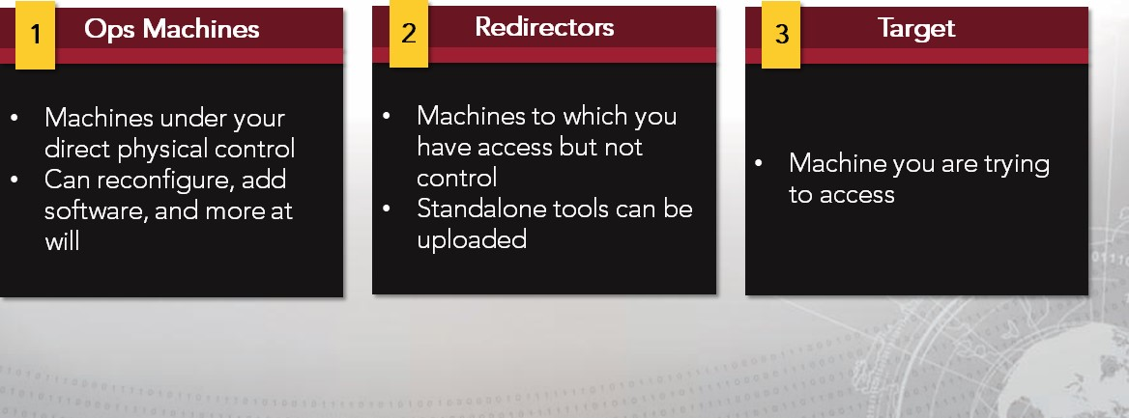

#### SSH Into Remote Machine

Sendmail Server IIS Server FTP Server

192 . 168 . 10 . 5 192 . 168 . 10 . 3 192 . 168 . 10 . 8



Connect to redirector, setup tunnel with redirector:

* ssh ad.rninistrator@192 .168. 10.3 —L5555: 192 . 168 .10 .8 :22 Connect to target host through tunnel:
* ssh root@127 .0.0. 1 —p 5555
* Network destination changes to local listener
* Username/password remain the same for the target host

#### Multiple Operations Boxes

By default, forward tunnels listen on localhost (127.0.0.1)

May want multiple ops boxes to access a tunnel: • Usually set up tunnels w/Linux (better SSH tools)

• Client may be Windows based (RDP, SMB)

Can configure using ssh syntax:



#### Multiple Operations Boxes

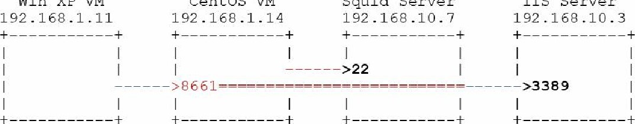

Win

xe

VM

centos

VM

Squid

Server

i

IS

Server

Set up tunnel on CentOS VM:

* ssh root@192.168.10.7

Connect to target from Windows XP VM:

* mstsc [v: 192.168.1.14:8661
* Log in using credentials for 192.168.10.3 (IIS Server)

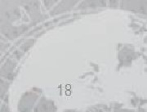

#### FTP Into Remote Machine

Centos VM Squid Server FTP Server

192 . 168 . 1 . 14 192 . 168 . 10 . 7 192 . 168 . 10 . 8



Set up tunnel:

 ssh root@192.168.1e.7

Connect to target via tunnel:

* ftp 127.e.e.1 3342

Get an FTP connect but cannot get data back. Why not?

Why Multi-Hop?

Multiple redirectors:

* Hide your original location better

Multiple targets:

* Ultimate target may be buried within network
* Multiple hops may be required to circumvent filtering and security devices



### Using Two Hops

Win 7 Physical Exchange Server Squid Server BSD Server

192 . 168 . 1 . 10 192 . 168 . 10 . 4 192 . 168 . 10 . 7 192 . 168 . 10 . 6

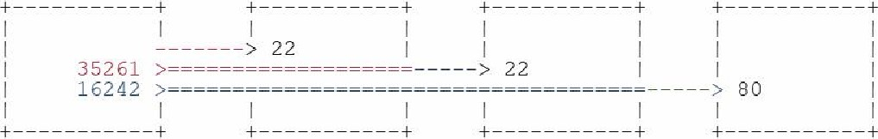

Connection to first redirector and first tunnel:

* ssh administrator@192.168.1e.4 -L 35261: 192.168.1e.7:22

Connection to second redirector and second tunnel via tunnel:

* ssh root@127.e.e.1 -p 35261 -L 16242: 192.168.1e.6:8e

Connect to target via tunnels:

* Point web browser at http://1 27.0.0.1: 16242

#### Public/Private

##### Often, one set of addresses is used for public access, while another is used for private

* Machines can have multiple network interfaces
* Network address translation (NAT)



* Addressing is done on a hop-by-hop basis
* If using public addressing to get beyond firewall/NAT, you need private addressing to redirect to hosts in the network

## Reverse Tunnels

Why?

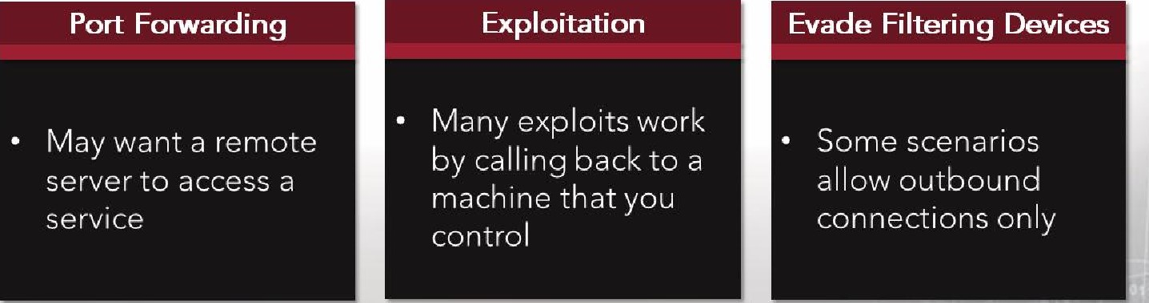

Common thread: The remote end initiates the TCP connection

## Reverse Tunnel Syntax

—R [<1 address>: port>:<dst ip> :<dst port >

* SSH server opens a socket listener on <l_port> on <l_address>
* Default address for -R is 0.0.0.0
* Client/server negotiates channel for tunnel
* When some remote machine connects to listener, packets are forwarded to SSH client through tunnel
* SSH client opens connection to <dst_ip> on <dst_port> and forwards packets



### Basic Port Forwarding

Sendmail Server Squid Server

192 . 168 . 10 . 5 1 92 . 168 . 10 . 7 outside



* SSH is already running on your machine Set up tunnel:
* ssh root@192. 168 . 10. 7
* Connect from outside the network:
* ssh root@192. 168 . 10. 7 -p 8022

## Reverse Tunnel Diagram

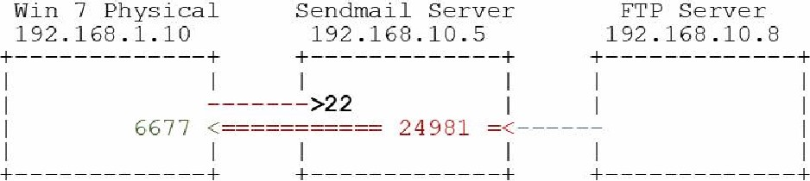

* Set up tunnel on Win 7 physical:
* ssh root@192.168.10.5 -R24981:127 .0.0.1:6677 Set up netcat listener on Win 7 physical:
* no -L -p 6677
* Connect from remote host on FTP server:

192 . 168 .10. 5 24981

### Multiple Hops: Reverse Tunnel

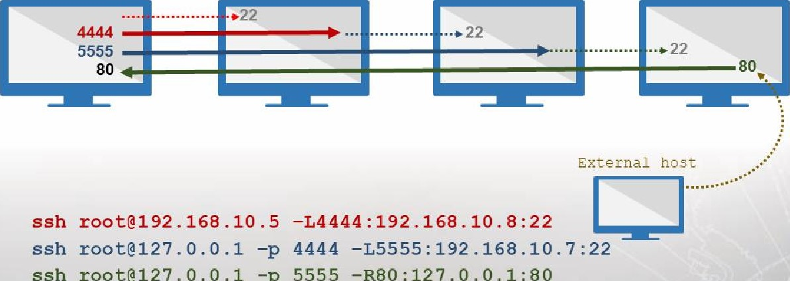

ssh

root@127.O.O.1

-p

5555

Web

Server

192.

168.

10.5

192

.

168

.10

.8

192.

168.

10.7

From Web Browser, go to URL: http://192 .168.10.7

### Additional Tunnels

* Suppose we want to add a tunnel after we have already set up our infrastructure
* Closing and reopening = bad OPSEC
* Native ssh command has built-in SSH prompt
* Entering —C in an open SSH window gives you a new prompt that allows you to set up tunnels:
* [root@localhost
* ssh>
* Forwarding port



[root@localhost

### Exercise: Tunneling and Data Exfiltration

Objectives

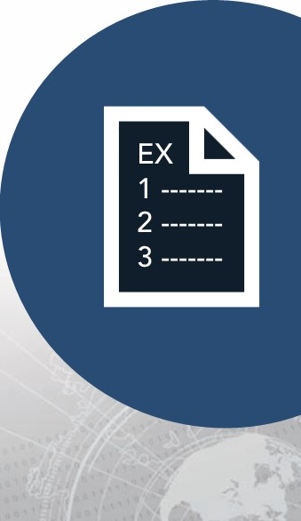After completing this exercise, students will be able to:

|  |  |
| --- | --- |
| Describe the principles and methods • | Analyze network tunneling diagrams |
| of tunneling network traffic | Describe SSH reverse tunnels and |
| Describe the different uses of SSH | their purpose |
| Describe the differences between | Recognize the difference between |
| forward and reverse tunnels when | tunneling and redirecting network |
| using SSH | traffic |
| Explain how to redirect traffic using | Implement reverse SSH tunnels |
| SSH forward and reverse tunnels | Analyze traffic to locate covert |
| Use SSH to redirect and tunnel | channels |

network traffic through multiple hosts

Duration

This exercise will take approximately 2.5 hours to complete.

### Exercise: Tunneling and Data Exfiltration

Note:

|  |  |
| --- | --- |
| Server |  |

Windows 10 10.1e.1.20

Centos 7 10.10.1.40

|  |  |
| --- | --- |
| Kali | 10.10.1.60 |
| Ubuntu | 10.1e.1.70 |

### Debrief

General Questions

* How did you feel about this section?
* Were there any areas in particular where you had difficulty?
* Do you understand how this relates to the work you will be doing?

### Summary

* From both a defensive and offensive perspective, SSH tunnels provide users with the assurance that their end-to-end communications are secure in a potentially hostile environment
* Attackers use secure tunneling to hide, obscure and redirect their traffic, subverting the security of existing infrastructure
* Network defenders must be familiar with the use and application of secure tunnels to counter network attacks and to detect and trace the origin of intrusions



|  |
| --- |
| End of Module 2, Lesson  7 |